##### **A Project Report on**

**DETECTION OF STRESS USING MACHINE LEARNING**

**Submitted in the partial fulfillment of the requirements for the Summer Internship of**

**BACHELOR OF TECHNOLOGY**

In

**INFORMATION TECHNOLOGY**

##### Submitted by

P.BHARATH 18017A12G0

P.SHIVA PRASAD 18017A12G1

C.NEHANTH REDDY 18017A12D4

G.SIVA SAI TEJA 18017A12E0



**DEPARTMENT OF INFORMATION TECHNOLOGY**

**VNR Vignana Jyothi Institute of Engineering & Technology**

(Autonomous Institute, Accredited by NAAC with ‘A++’ grade and NBA)

##### Bachupally, Nizampet (S.O.) Hyderabad- 500 090, August 2020 **.**

**Under the esteemed guidance of**



**PROJECT GUIDE**

Mr. Sravan Kumar ,

Assistant Professor,

Dept. of Information Technology,

VNRVJIET.

**DEPARTMENT OF INFORMATION TECHNOLOGY**

**VNR Vignana Jyothi Institute of Engineering & Technology** (Autonomous Institute, Accredited by NAAC with ‘A++’ grade and NBA) Bachupally, Nizampet (S.O.) Hyderabad- 500 090,July 2020

**VNR Vignana Jyothi Institute of Engineering & Technology**

Autonomous Institute, Accredited by NAAC with ‘A++’ grade and NBA) Bachupally, Nizampet (S.O.) Hyderabad- 500 090

**Department of Information Technology**

Date: July 2020



**CERTIFICATE**

This is to certify that the project work entitled **“ DETECTION OF DEGREE OF STRESS USING MACHINE LEARNING”** is being submitted by **P.BHARATH (18071A12G0), P.SHIVA PRASAD (18071A12G1), C.NEHANTH REDDY (18071A12D4), SIVA SAI TEJA (18071A12E0)** in partial fulfillment for the award of Degree of **BACHELOR OF TECHNOLOGY** in **INFORMATION TECHNOLOGY** to the Jawaharlal Nehru Technological University, Hyderabad during the academic year 2019-20 is a record of bona-fide work carried out by under our guidance and supervision.

The results embodied in this report have not been submitted by the students to any other University or Institution for the award of any degree or diploma.

**Project Guide Head of Department**

**MR.SRAVAN KIRAN, Dr. G. SURESHREDDY**

**Assistant Professor, Head of Department,**

**Dept. Of IT, Dept. Of IT,**

**VNRVJIET, VNRVJIET,**

**Hyderabad. Hyderabad**

**VNR Vignana Jyothi Institute of Engineering & Technology**

Autonomous Institute, Accredited by NAAC with ‘A++’ grade and NBA) Bachupally, Nizampet (S.O.) Hyderabad- 500090.

**Department of InformationTechnology**

Date: July 2020

#### **DECLARATION**

##### I hereby declare that the project entitled “Detection Of Degree Of Stress” submitted for the B.Tech Degree is my original work and the project has not formed the basis for the award of any degree, associate ship, fellowship or any other similar titles.

**Signature of the Student:**

P.BHARATH P.SHIVA PRASAD C.NEHANTH REDDY SIVA SAI TEJA

(18071A12G0) (18071A12G1) (18071A12D4) (18071A12E0)

**ACKNOWLEDGEMENT**

We express our deep sense of gratitude to our beloved **President, Dr.D.N.Rao, VNR Vignana Jyothi Institute of Engineering &Technology** for the valuable guidance and for permitting us to carry out this project.

With immense pleasure, we record our deep sense of gratitude to our beloved **Principal, Dr.C.D.Naidu** for permitting us to carry out this project.

We express our deep sense of gratitude to our beloved professor **G.Suresh Reddy, Associate Professor and Head, Department of Information Technology, VNR Vignana Jyothi Institute of Engineering & Technology, Hyderabad-90** for the valuable guidance and suggestions, keen interest and through encouragement extended throughout period of project work.

We take immense pleasure to express our deep sense of gratitude to our beloved Guide **Mr.Sravan Kiran, Assistant Professor in Information Technology, VNR Vignana Jyothi Institute of Engineering & Technology, Hyderabad,** for his valuable suggestions and rare insights, for constant source of encouragement and inspiration throughout my project work.

We express our thanks to all those who contributed for the successful completion of our project work.

1. P.BHARATH

1. P.SHIVA PRASAD

1. C.NEHATH REDDY

1. SIVA SAI TEJA

**INDEX**

**S NO CONTENTS PAGE NUMBER’S**

1. **Abstract 8**

**2 Chapter-1: Introduction 9**

**3 1.1 Purpose of the project 9**

**4 Chapter-2: Literacy Survey 10 - 12**

**5 2.1 - Related Research 10 - 11**

**6 2.2 - Existing System 11 - 12**

**7 2.3 - Limitations of the Existing System 12**

**8 Chapter-3: Proposed System 13 - 14**

**9 Chapter-4: Proposed Work 15 - 19**

**10 4.1: Dataset 15**

**11 4.2: Data analyzing and data mining 16**

**12 4.3: Visualizations 16 - 19**

**13 Chapter-5: Model Building 20 - 22**

**14 5.1: Bit Of Theory 20**

**15 5.2: Bit Of Math 20 - 21**

**16 5.3: Data Cleaning 21 - 22**

**17 5.4: Converting Categorical Values 22**

**18 5.5: Splitting The Data 22**

**19 5.6: Accuracy 22**

**20 Chapter – 6: Implementation 23 - 41**

**S NO CONTENTS PAGE NUMBER’S**

1. **6.1 : Source Code 23 - 37**
2. **6.2 : Deployment using Flask 38**

**23 6.3: HTML code for web page 39 - 40**

**24 6.4: Our user interface 41**

**25 Chapter 7: Results 42 - 46**

**26 Chapter 8:Conclusion 47**

**27 Chapter 9: References 48**

**Abstract**

Every year tens of millions of people suffer from depression and few of them get proper treatment on time and some of them are not. This depression is the result of heavy stress .Every nine out of ten are suffering with stress because of work-overload ,family problems etc.. So, it is necessary to know whether the person is stressed if then he/she should be treated before stepping into danger situation which leads to problems like Heart Stoke, Depression etc...So we came up with a beautiful solution in detecting whether he/she is stressed or not. For that we built a Machine Learning model which will detect whether the person is stressed or not. We built the model by giving the basic parameters like age, gender, family history(like family problems), work problems etc..We gave up to 10 parameters and trained the model. The model finally predicts whether the person requires treatment or not. All this are back-end process. In front-end a web application will be visible to the user which is written using HTML and CSS through which the user can give the input and predicted result will be displayed as the pop up message as whether he/she requires treatment or not.

**CHAPTER -1**

**INTRODUCTION**

**DEFINATION:**

Stress is a body’s method for reacting to a challenge. Human Stress can have an impact on a person’s mental and physical well-being. Stress can lead to a change in behaviour and in physiology. Many people suffer from stress in everyday life. Stress is related to human work in one way or other. Originates of stress have different sources such as time pressure while working in company, responsibility, economic problem or physical factors such as noise. Signs of stress are human fell tension, anxious, angry, frustrated or irritated by things over which he has no control.

**1.1 PURPOSE OF THE PROJECT:**

Stress detection is an on-going research topic among both psychologists and engineers. Wearable sensors and bio signal technologies are developed for detecting the human stress. There are various bio signal processing technologies use for human stress detection such as Electroencephalography(EEG), Electrocardiography(ECG), Electromyography (EMG), Blood Pressure(BP) ,Blood Volume Pulses(BVP), Galvanic Skin Resistance(GSR), Respiration and Skin Temperature(ST) etc.. Also to measure the stress level human physiological features are used. Person physiological features changes when he/she response to stressful events. By considering various physiological features occur in human while he/she is in stress the estimation is stress are done by using cluster based analysis method.

In proposed method Machine Learning technology which is trending now-a-days is used.Since Machine Learning leads to building of model for prediction of outcome which in turn for building a model it should require some data for training which in turn requires collection of dataset. Here in the proposed method we used the dataset which consist of 1600 records for training the model. The attributes in the dataset are up-to 12 which include some common factors which are responsible for stress. These attributes includes hours of work, family problems, insufficient income ,age,carrier options etc..This trained model is connected to a web application which is written using HTML and CSS. So the user can easily know whether the person need treatment or not..High level and average level stress values people should get treatment and low level stress values people no need of taking treatment according to the model we built.

**CHAPTER-2**

**LITERATURE SURVEY**

A literature review is conducted over analysis of stress and detection of stress level which are done by previously by our senior citizens. By this we came to know that everyone who are worked on the detection of stress used the parameters provided by some electronic devices like ECG, EEG etc… Some of the previous methods are shown below:

### 2.1-Related Research

### Previous work on stress measurement has been focused on the collection and analysis of physiological data and the identification of the correlation between perceived stress and multiple physiological features.

**Qianli Xu, Tin Lay Nwe, and Cuntai Guan(2015) :**

Proposes a novel Cluster-Based Analysis method to measure stress using physiological signals, which accounts for inter-subject differences. This research uses the clustering process that assigns the subject into subgroups, So as to exploit the inherent homogeneity of subject’s stress response within the cluster. Thus the inter-subject differences are automatically accommodated and the overall accuracy of stress evaluation is improved.

**Chee-Keong Alfred Lim and Wai Chong Chia(2015):**

Focuses on evaluating to what extent a single electrode EEG headset - NeuroSky Mindwave is able to classify brainwave in terms of subject’s stressor level. In this study they use the MATLAB environment for processing the EEG signals. By reducing the number of electrodes needed. It also means cheaper EEG headset can be used to diagnose various mental disorders.

**Tong chen, Peter Yuen, Mark Richardson, Guangyuan Liu and Zhishun She(2014):**

Detect psychological stress in a non-contact manner using a human physiological responce.

**Cornelia setz, Bert Arnrich, Johannes Schumm, Roberto La Marco, Gerhand Troster, and Ulrike Ehlert(2010):**

Developed a personal health system for detecting the stress. They use the discriminative power of electro dermal activity(EDA). This EDA power is use for distinguishing stress from office work load. They do the analysis on EDA data and evaluate the info about stress level of a person

**Awanis Romli Arnidcha peri cha(20009):**

Suggested a system which deals with stress management. They change the manual system into computerized one. This system does the stress management for particular individual based on their activity interest and provides a solution for stress management. This system using combination of rule based technique and Holland’s Self Directed Search Model to determine the best solution for managing the stress. This system use Rule-Based technique. In this technique user is given a test to develop the system’s knowledge-based. From this test system can determine the user’s interest behavior and through their thinking the system gives the best solution to manage user’s stress according to their interest.

**Jennifer A. Healey and Rosalind W.Picard (2005):**

Shows how physiological data is useful during real-world driving task to determine a driver’s relative stress level. In this study they show how physiological sensor can be used to obtain electrical signals that can be processed automatically by an on-board computer to give dynamic indications of a driver’s natural state under natural driving conditions. The experiment was design to monitor the driver’s physiological reaction during real-world driving situation under normal condition.

### 2.2 Existing System

### Existing system proposes a novel cluster based analysis method to measure perceived stress using physiological signals, which accounts for the inter-subject differences.

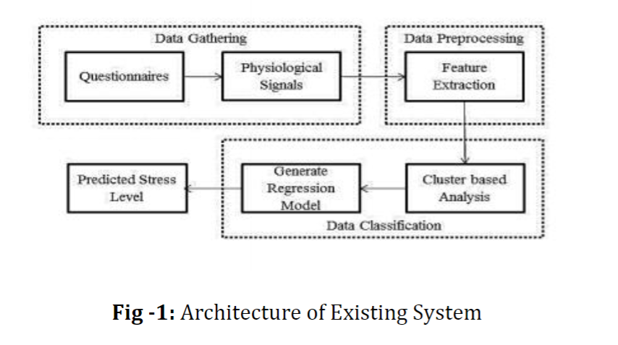

The system contains three stages Data Gathering, Data Preprocessing and Data Classification. Data is collected by using wireless sensors. Wireless sensor was used to collect a subject’s physiological signals. Data processing discover the useful info. This is responsible for collecting raw data and converting it into info useful for decision making by users. It does the feature extraction on data means redundancy in the dataset is reduced by this process. In Data classification mode feature extracted data are used to classified subjects into different classes.

### 2.3-Limitations of the Existing System

### There are various researches are going on human stress detection and estimation of stress. But everyone is worked and still working on the data that is giving by the ECG machines or some mechanical instruments. But we know that every individual is not capable or affordable for those ECG testing which are not provided freely. And the values given by the signals are not understandable..

So it is necessary to bring a machine or application that asks for the user’s convenient data like understandable data based on that data it should predict the stress.

So, in this paper we are going elaborate about how to satisfy this limitations and come up with a application by which everyone can access through their smart phones and can detect the stress with simple data.

**CHAPTER-3**

### Proposed System

In the proposed system we detected the stress of a person by giving the simple inputs that are easily available for every individual’s. By giving the data we predicted whether the person is heavily stress or average stressed else not stressed. If a person is heavily or average stressed the we predicted output as he/she need the treatment and the application through which all this run will give them suggestion that treatment is necessary for him/her. The architecture of the proposed system is shown below

Dataset : Importing dataset

Filling Null Values:Replacing them with mean or mode

Data Analysis :

Feature Extraction

Deployment:Connecting python program to the web application written using html

Connecting model to python program using pickle

NaiveBayes model preparation

**Fig 3.1:** Flow chart proposed system

In the proposed approach we predict the stress and provide suggestion whether to take treatment or not by building a ML model using Naive Bayes algorithm. The model works with an accuracy of 85%.The following are the steps involved in building the model and deploying it.

* Importing dataset
* Important feature extraction using matplotlib library by knowing relation between parameters
* Filling null values with mean or mode.
* Building model using Naive Bayes Algorithm
* Connecting model to python program and executing it through web application on local host sever.

### Software's Required :

1. Any python IDE like jupyter notebook etc..
2. Any python we application development environment using flask like Spyder.
3. Any search engine for web application.
4. Notepad for building html file

**CHAPTER-4**

**PROPOSED WORK**

**4.1 DATASET**

Since we know that dataset is the main part for building any model that predicts an outcome. We collected the dataset from the internet which consist of parameters as which are the questions asked to the citizens in different countries. The parameters include **Timestamp(**Time the survey was submitted**)** ,**Age(**Respondent age**),Gender(**Respondent gender),**Country(**Respondent country**),state(**If you live in the United States, which state or territory do you live in?**), self employed(**Are you self-employed?**),family history(**Do you have a family history of mental illness?**),treatment(**Have you sought treatment for a mental stress condition?**),work interfere(**If you have a mental stress condition, do you feel that it interferes with your work?**),no employees(**How many employees does your company or organization have?**),remote work(**Do you work remotely (outside of an office) at least 50% of the time?**),tech company(**Is your employer primarily a tech company/organization?**),benefits(**Does your employer provide mental stress benefits?**),care options(**Do you know the options for mental health care your employer provides?**),wellness program(**Has your employer ever discussed mental stress as part of an employee wellness program?**),seek help(**Does your employer provide resources to learn more about mental stress issues and how to seek help?**),anonymity(**Is your anonymity protected if you choose to take advantage of mental stress or substance abuse treatment resources?**),leave**(How easy is it for you to take medical leave for a mental health condition?),**mental health consequence(**Do you think that discussing a mental stress issue with your employer would have negative consequences?**),phys health consequence(**Do you think that discussing a physical health stress with your employer would have negative consequences?**),coworkers(**Would you be willing to discuss a mental stress issue with your coworkers?**),supervisor(**Would you be willing to discuss a mental stress issue with your direct supervisor(s)?**) etc..**Like this there are about 27 columns for training our model. The labelled data in this or the one we predict from the dataset is whether he need treatment or not means treatment column is taken as labelled data..If the predicted output is yes them stress level according to the given data is lies between Average- High If it is no then stress level is low.

**4.2 DATA ANALYSIS AND MINING**

It is important to find out the effective data or parameters that are useful for our model. If we include all the parameters without mining so due to outliers and due to some un useful data the model accuracy will be reduced. So, to avoid these kind of problems it is important to dig out the important data. For digging out the important parameters we used many methods. Firstly, we used back propagation method and based on the p values we taken out some useful data. Secondly, by plotting the graphs between the input and output parameters we taken out some useful data. So at last after digging out all the useful data by different methods we came up with only these parameters **Age,Gender,Family_history,Benefits,Care_options,Anonymity,Leave,Work_interfere,Treatment.**

### 4.3 Visualizations:

From the below graph it is clear that the questions asked to the individuals includes all generation one’s like children, adults, old one. But the one who answered questions are mainly are from the age between 25-45. And a few of some 5 to 6 members belongs to age above 70 are answered.

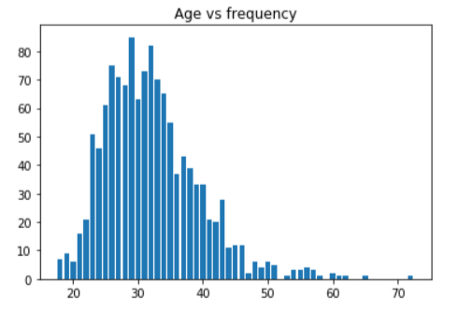

**Fig 4.3.1:** Age Vs Frequency

The Second graph explains about the gender of the people who answered to the question from the above graph it is clear that most of the people who answered are women with frequency of 991 and then men with frequency of 247 and last trans with the frequency of 19 and after the encoding categorical one’s into numerical the representations are:

Female -0

Male - 1

Trans -2

**Note:** Users should give input data in the user interface in the above mentioned form only.

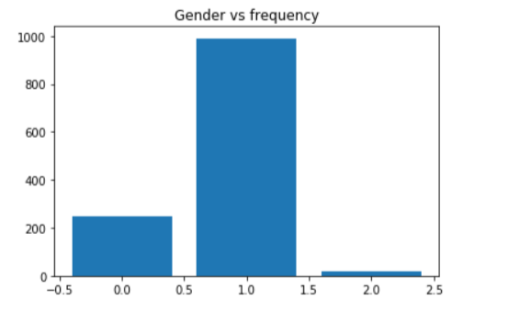

**Fig 4.3.2 :** Gender Vs Frequency

The below graph shows the relation between the question whether there work causes any pressure or stress to them or not and their respective frequency..Many of them answered that it causes sometimes and the least one’s is often it causes and others like rarely and Never and Don’t Know.

Here in the graph:

Don’t Know-0

Never - 1

Often – 2

Rarely - 3

Sometimes – 4

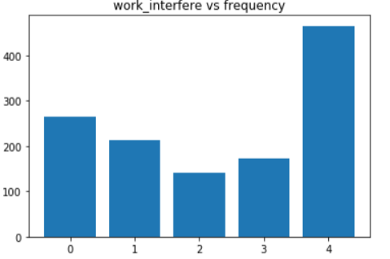

**Fig 4.3.3:** work interfere Vs frequency

The below graph gives relation between the question how many of them are self employed and how many are not when we look at the graph many of them are unemployed and few of them are employed.

Here,

No-0

Yes-1

**Note:** User’s should use the same format while giving input in user interface.

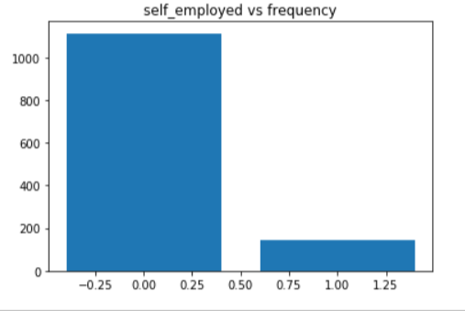

**Fig 4.3.4:** self employed Vs frequency

Here ,the another one shows about the how many of these individuals have that stress from their family history like whether did anyone faced that stress problem in there family .From the graph it is clear that only few of them are facing it from there family and many of them are not..

Here, No-0, Yes-1

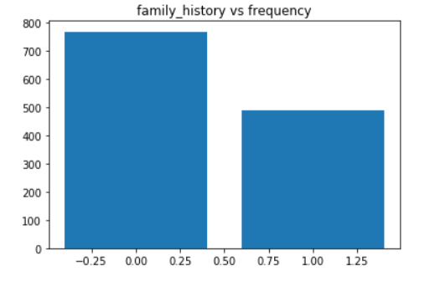

**Fig 4.3.5:** family history Vs frequency

There are many more relations that can we easily understandable. For now we will continue with some other remaining features values what users should give in the user interface..

* **Care options :**User values should be -

No - 0

Not Sure - 1

Yes – 2

* **Benefits :** User values should be -

Don’t know - 0

No - 1

Yes – 2

* **Anonymity :** User values should be :

Don’t Know - 0

No - 1

Yes – 2

* **Leave :** User values should be :

Don’t know – 0, Somewhat difficult - 1 , Somewhat easy - 2 , Somewhat easy - 2 , Very difficult - 3

Very easy – 4

**CHAPTER-5**

**MODEL BUILDING**

# 5.1 A BIT OF THEORY

Naive Bayes classification is a simple probability algorithm based on the fact, that all features of the model are independent. In the context of the detection of stress we suppose, that feature is independent we count them with the ignorance of the context (any diff value like male, M, ).Calculating the probability or likelihood of observing a given real-value like X1 is difficult.

One way we can do this is to assume that X1 values are drawn from a distribution, such as a bell curve or Gaussian distribution. A Gaussian distribution can be summarized using only two numbers: the mean and the standard deviation. Therefore, with a little math, we can estimate the probability of a given value. This piece of math is called a Gaussian Probability Distribution Function (or Gaussian PDF) and can be calculated as:

f(x) = (1 / sqrt(2 * PI) * sigma) * exp(-((x-mean)^2 / (2 * sigma^2)))

Where sigma is the standard deviation for x, mean is the mean for x and PI is the value of pi.

So, how does the algorithm work?

**5.2 A BIT OF MATH**

Probability of stress that contains people who has stress is porportional to the probability to get stress multiplied by a product of probabilities for every person who has stress. What does mean for every people who has stress, we calculate a probability of it to be found in stress

**Age (**Respondent age**)**

**Gender (**Respondent gender)

**Self employed (**Are you self-employed?**)**

**Family history (**Do you have a family history of mental illness?

**Treatment (**Have you sought treatment for a mental stress)

**Benefits (**Does your employer provide mental stress benefits?**)**

**Anonymity (**Is your anonymity protected if you choose to take advantage of mental stress or substance abuse treatment resources?**)**

**Care options (**Do you know the options for mental health care your employer provides?**)**

**Leave** (How easy is it for you to take medical leave for a mental health condition?)

There are the main variables to find a person is affected stress or not.

**5.3 DATA CLEANING**

Before algorithm application we need to prepare data. We have dropped time stamp, country, state and comments from data set because they are not important .we have checked whether the data contains null values or not now we had checked dataset for knowing what type of data types are they. We have counted different types of answers given by public for gender question. We assigned default values for each data type like default integer should be 0. We differentiated int features and string features and cleaned NaN values. Now we checked the dataset have any null values or not, there are no null values in dataset. Now we will find variety of answers given by public for gender without number of times. We will convert all gender values in lower case. After changing into lower case, we changed all different types on answers in male list to male, female list to female and trans list trans by iterating through each row. Now we filled missing age with median. We have filled <18 and >120 age values with median.

**5.4 CONVERTING CATEGORICAL VALUES**

Converting categorical age range into understandable type like 0-20 age is given by 0.21-30 is given by 20.in this data there are only 0.014% of self employed so we have changed NaN to NOT self employed. There are only 0.20% of self work interface so we have changed NaN to don’t know. Now for each categorical column we replaced each category with the class. If there are 3 diff categories column is given a 0, 1, 2. **Encoding** of data is done.

**5.5 SPLITTING THE DATASET**

We define X=feature columns= Age, Gender, family history, benefits, care options, anonymity, leave, work interfere. And Y= treatment. Now we split-ted X, Y into training and testing sets.

**5.6 ACCURACY**

After splitting those variables into train and test data, we will generate naïve bayes model on training set and perform prediction on test set. After model generation we can check accuracy using actual and predicted values. We got an accuracy of 82%.

**CHAPTER-6**

**IMPLEMENTATION**

**6.1 SOURCE CODE:-**

**1. Importing Libraries**

import pandas as pd

import numpy as np

import matplotlib.pyplot as plt

import seaborn as sns

from sklearn.metrics import confusion_matrix

from sklearn.preprocessing import LabelEncoder

import statsmodels.api as sm

from sklearn.preprocessing import StandardScaler

from sklearn.model_selection import train_test_split

import random

from sklearn.tree import DecisionTreeClassifier

from sklearn.metrics import accuracy_score

from sklearn.naive_bayes import GaussianNB

**2.Importing Dataset**

dataset=pd.read_csv("stress.csv")

dataset

**3.Data Mining(Removing unwanted data) and replacing null values and converting categorical to known type(int).**

#when we look at the dataset it is clearly stating that timestamp is not so important column. So we can drop it.

dataset.drop("Timestamp",axis=1,inplace=True)

dataset

#checking whether dataset contains any null values

dataset.isnull().any()

#state and comments are not necessary so we can drop down them.

dataset.drop("state",axis=1,inplace=True)

dataset.drop("comments",axis=1,inplace=True)

dataset

#Again checking for null values

dataset.isnull().any()

#picking to 5 records and analysing them

dataset.head()

#knowing datatypes of each column

dataset.dtypes

#counting the different types of answers for the Gender question

dataset["Gender"].value_counts()

# Assign default values for each data type

defaultInt = 0

defaultString = 'NaN'

defaultFloat = 0.0

# Create lists by data tpe

intFeatures = ['Age']

stringFeatures = ['Gender', 'Country', 'self_employed', 'family_history', 'treatment', 'work_interfere',

'no_employees', 'remote_work', 'tech_company', 'anonymity', 'leave', 'mental_health_consequence',

'phys_health_consequence', 'coworkers', 'supervisor', 'mental_health_interview', 'phys_health_interview',

'mental_vs_physical', 'obs_consequence', 'benefits', 'care_options', 'wellness_program',

'seek_help']

floatFeatures = []

# Clean the NaN's

for feature in dataset:

if feature in intFeatures:

dataset[feature] = dataset[feature].fillna(defaultInt)#filling with 0

elif feature in stringFeatures:

dataset[feature] = dataset[feature].fillna(defaultString)#filling with category NAN means replacing Not a number one

elif feature in floatFeatures:

dataset[feature] = dataset[feature].fillna(defaultFloat)

else:

print('Error: Feature %s not recognized.' % feature)

dataset.isnull().any()

#knowing variety of answers for Gender question without no of times

dataset['Gender'].unique()

#converting to lower cases each answer for the Gender

gender = dataset['Gender'].str.lower()

print(gender)

gender = dataset['Gender'].unique()

#storing all male ones in one list and female ones in another and trans ones to another list

male_str = ["male", "m", "male-ish", "maile", "mal", "male (cis)", "make", "male ", "man","msle", "mail", "malr","cis man", "Cis Male", "cis male"]

trans_str = ["trans-female", "something kinda male?", "queer/she/they", "non-binary","nah", "all", "enby", "fluid", "genderqueer", "androgyne", "agender", "male leaning androgynous", "guy (-ish) ^_^", "trans woman", "neuter", "female (trans)", "queer", "ostensibly male, unsure what that really means"]

female_str = ["cis female", "f", "female", "woman", "femake", "female ","cis-female/femme", "female (cis)", "femail"]

#changing all different types of answers in male list to male and female list ones to female and trans list one's to trans by iterating through each row

for (row, col) in dataset.iterrows():

if str.lower(col.Gender) in male_str:

dataset['Gender'].replace(to_replace=col.Gender, value='male', inplace=True)

if str.lower(col.Gender) in female_str:

dataset['Gender'].replace(to_replace=col.Gender, value='female', inplace=True)

if str.lower(col.Gender) in trans_str:

dataset['Gender'].replace(to_replace=col.Gender, value='trans', inplace=True)

#looking whether they are changed or not

dataset['Gender'].unique()

#removing out the one that is anwered in an un-understandable manner

stk_list = ['A little about you', 'p']

dataset = dataset[~dataset['Gender'].isin(stk_list)]#removing rows which consist this kind of info in Gender col

#checking once again

dataset['Gender'].unique()

dataset['Gender']

dataset['Age'].fillna(dataset['Age'].median(),inplace=True)

s=pd.Series(dataset['Age'])

s

s<18

s[s<18]=dataset['Age'].median()

dataset['Age']=s

s=pd.Series(dataset['Age'])

s[s>120]=dataset['Age'].median()

dataset['Age']=s

dataset

#Converting categorical age_range to the understandable type

#Ranges of Age

dataset['age_range'] = pd.cut(dataset['Age'], [0,20,30,65,100], labels=["0-20", "21-30", "31-65", "66-100"], include_lowest=True)

dataset['age_range']

dataset

#There are only 0.014% of self employed so let's change NaN to NOT self_employed

#Replace "NaN" string from defaultString

dataset['self_employed'] = dataset['self_employed'].replace([defaultString], 'No')

print(dataset['self_employed'].unique())

dataset['self_employed'].value_counts()

#There are only 0.20% of self work_interfere so let's change NaN to "Don't know

#Replace "NaN" string from defaultString

dataset['work_interfere'] = dataset['work_interfere'].replace([defaultString], 'Don\'t know' )

print(dataset['work_interfere'].unique())

dataset1=dataset.iloc[:,1:]

dataset1

#for each categorical column we replaced the each caregory with the class..means if there are 5 diff categories a column one is given as o and then 1 and 2 and 3 and 4

for feature in dataset1:

le = LabelEncoder()

le.fit(dataset1[feature])

le_name_mapping = dict(zip(le.classes_, le.transform(le.classes_)))#mapping a number to each category

dataset1[feature] = le.transform(dataset1[feature])

dataset1.head()

k=pd.Series(dataset['Age'])

dataset1['Age']=k

dataset1

dataset=dataset1

dataset

#correlation between each parameters

sns.heatmap(dataset.corr(),annot=True)

dataset

dataset=dataset[['Gender','Country','self_employed','family_history','work_interfere','no_employees','remote_work','tech_company','benefits','care_options','wellness_program','seek_help','anonymity','leave','mental_health_consequence','phys_health_consequence','coworkers','supervisor','mental_health_interview','phys_health_interview','mental_vs_physical','obs_consequence','Age','treatment']]

dataset

x=dataset.iloc[:,0:23].values

x

y=dataset.iloc[:,23:].values

y

fig,ax=plt.subplots()

data=dataset['Age'].value_counts()

points=data.index

frequency=data.values

ax.bar(points,frequency)

ax.set_title('Age vs frequency')

ax.set_label('Age')

ax.set_label('Frequency')

fig,ax=plt.subplots()

data=dataset['Gender'].value_counts()

points=data.index

frequency=data.values

ax.bar(points,frequency)

ax.set_title('Gender vs frequency')

ax.set_label('Gender')

ax.set_label('Frequency')

fig,ax=plt.subplots()

data=dataset['work_interfere'].value_counts()

points=data.index

frequency=data.values

ax.bar(points,frequency)

ax.set_title('work_interfere vs frequency')

ax.set_label('work_interfere')

ax.set_label('Frequency')

fig,ax=plt.subplots()

data=dataset['benefits'].value_counts()

points=data.index

frequency=data.values

ax.bar(points,frequency)

ax.set_title('benefits vs frequency')

ax.set_label('benefits')

ax.set_label('Frequency')

fig,ax=plt.subplots()

data=dataset['self_employed'].value_counts()

points=data.index

frequency=data.values

ax.bar(points,frequency)

ax.set_title('self_employed vs frequency')

ax.set_label('self_employed')

ax.set_label('Frequency')

fig,ax=plt.subplots()

data=dataset['family_history'].value_counts()

points=data.index

frequency=data.values

ax.bar(points,frequency)

ax.set_title('family_history vs frequency')

ax.set_label('family_history')

ax.set_label('Frequency')

fig,ax=plt.subplots()

data=dataset['care_options'].value_counts()

points=data.index

frequency=data.values

ax.bar(points,frequency)

ax.set_title('care_options vs frequency')

ax.set_label('care_options')

ax.set_label('Frequency')

fig,ax=plt.subplots()

data=dataset['leave'].value_counts()

points=data.index

frequency=data.values

ax.bar(points,frequency)

ax.set_title('leave vs frequency')

ax.set_label('leave')

ax.set_label('Frequency')

fig,ax=plt.subplots()

data=dataset['anonymity'].value_counts()

points=data.index

frequency=data.values

ax.bar(points,frequency)

ax.set_title('anonymity vs frequency')

ax.set_label('anonymity')

ax.set_label('Frequency')

Feature Extraction

x_opt=np.array(x[:,[0,1,2,3,4,5,6,7,8,9,10,11,12,13,14,15,16,17,18,19,20,21,22]],dtype=float)

regressor_OLS=sm.OLS(endog=y,exog=x_opt).fit()

regressor_OLS.summary()

x_opt=np.array(x[:,[0,1,2,3,4,5,7,8,9,10,11,12,13,14,15,16,17,18,19,20,21,22]],dtype=float)

regressor_OLS=sm.OLS(endog=y,exog=x_opt).fit()

regressor_OLS.summary()

x_opt=np.array(x[:,[0,1,2,3,4,5,7,8,9,10,11,12,14,15,16,17,18,19,20,21,22]],dtype=float)

regressor_OLS=sm.OLS(endog=y,exog=x_opt).fit()

regressor_OLS.summary()

x_opt=np.array(x[:,[0,1,2,3,4,5,7,8,9,10,11,12,15,16,17,18,19,20,21,22]],dtype=float)

regressor_OLS=sm.OLS(endog=y,exog=x_opt).fit()

regressor_OLS.summary()

x_opt=np.array(x[:,[0,1,2,3,4,5,7,8,9,10,11,12,15,16,17,18,19,21,22]],dtype=float)

regressor_OLS=sm.OLS(endog=y,exog=x_opt).fit()

regressor_OLS.summary()

x_opt=np.array(x[:,[0,1,2,3,4,5,7,8,9,10,11,12,15,16,17,19,21,22]],dtype=float)

regressor_OLS=sm.OLS(endog=y,exog=x_opt).fit()

regressor_OLS.summary()

x_opt=np.array(x[:,[0,1,2,3,4,5,7,8,9,11,12,15,16,17,19,21,22]],dtype=float)

regressor_OLS=sm.OLS(endog=y,exog=x_opt).fit()

regressor_OLS.summary()

x_opt=np.array(x[:,[0,1,2,3,4,5,7,8,9,11,12,16,17,19,21,22]],dtype=float)

regressor_OLS=sm.OLS(endog=y,exog=x_opt).fit()

regressor_OLS.summary()

x_opt=np.array(x[:,[0,1,2,3,4,5,7,8,9,11,12,16,17,19,21]],dtype=float)

regressor_OLS=sm.OLS(endog=y,exog=x_opt).fit()

regressor_OLS.summary()

x_opt=np.array(x[:,[0,1,3,4,5,7,8,9,11,12,16,17,19,21]],dtype=float)

regressor_OLS=sm.OLS(endog=y,exog=x_opt).fit()

regressor_OLS.summary()

x_opt=np.array(x[:,[0,1,3,4,7,8,9,11,12,16,17,19,21]],dtype=float)

regressor_OLS=sm.OLS(endog=y,exog=x_opt).fit()

regressor_OLS.summary()

x_opt=np.array(x[:,[0,3,4,7,8,9,11,12,16,17,19,21]],dtype=float)

regressor_OLS=sm.OLS(endog=y,exog=x_opt).fit()

regressor_OLS.summary()

x_opt=np.array(x[:,[0,3,4,8,9,11,12,16,17,19,21]],dtype=float)

regressor_OLS=sm.OLS(endog=y,exog=x_opt).fit()

regressor_OLS.summary()

**5. Model Building**

dataset=dataset[['Age', 'Gender', 'family_history', 'benefits', 'care_options', 'anonymity', 'leave', 'work_interfere']]

dataset

x=dataset.iloc[:,0:].values

x

y

sc=StandardScaler()

x=sc.fit_transform(x)

x

from joblib import dump

dump(sc,"StandardScalar.save")

X_train, X_test, y_train, y_test = train_test_split(x, y, test_size=0.30, random_state=0)

x

y

dt=DecisionTreeClassifier(max_depth=3,max_features=6,min_samples_split=5,min_samples_leaf=6,criterion="entropy",random_state=0)

dt.fit(X_train,y_train)

accuracy_score(y_test,dt.predict(X_test))

g=GaussianNB()

g.fit(x,y)

import pickle

pickle.dump(g,open('GaussianNB.pkl','wb'))

x_test

y_pred=g.predict(X_test)

y_pred

**6.Accuracy Test**

accuracy_score(y_test,y_pred)

sns.heatmap(confusion_matrix(y_test,y_pred),annot=True)

**\*Head of the dataset**

| **Age** | **Gender** | **Country** | **self_employed** | **family_history** | **treatment** | **work_interfere** | **no_employees** | **remote_work** | **tech_company** | **...** | **anonymity** | **leave** | **mental_health_consequence** | **phys_health_consequence** | **coworkers** | **supervisor** | **mental_health_interview** | **phys_health_interview** | **mental_vs_physical** | **obs_consequence** |
| --- | --- | --- | --- | --- | --- | --- | --- | --- | --- | --- | --- | --- | --- | --- | --- | --- | --- | --- | --- | --- |
| **0** | 37 | Female | United States | NaN | No | Yes | Often | 6-25 | No | Yes | ... | Yes | Somewhat easy | No | No | Some of them | Yes | No | Maybe | Yes | No |
| **1** | 44 | M | United States | NaN | No | No | Rarely | More than 1000 | No | No | ... | Don't know | Don't know | Maybe | No | No | No | No | No | Don't know | No |
| **2** | 32 | Male | Canada | NaN | No | No | Rarely | 6-25 | No | Yes | ... | Don't know | Somewhat difficult | No | No | Yes | Yes | Yes | Yes | No | No |
| **3** | 31 | Male | United Kingdom | NaN | Yes | Yes | Often | 26-100 | No | Yes | ... | No | Somewhat difficult | Yes | Yes | Some of them | No | Maybe | Maybe | No | Yes |
| **4** | 31 | Male | United States | NaN | No | No | Never | 100-500 | Yes | Yes | ... | Don't know | Don't know | No | No | Some of them | Yes | Yes | Yes | Don't know | No |

5 rows × 24 columns

**6.2 Deployment using Flask :**

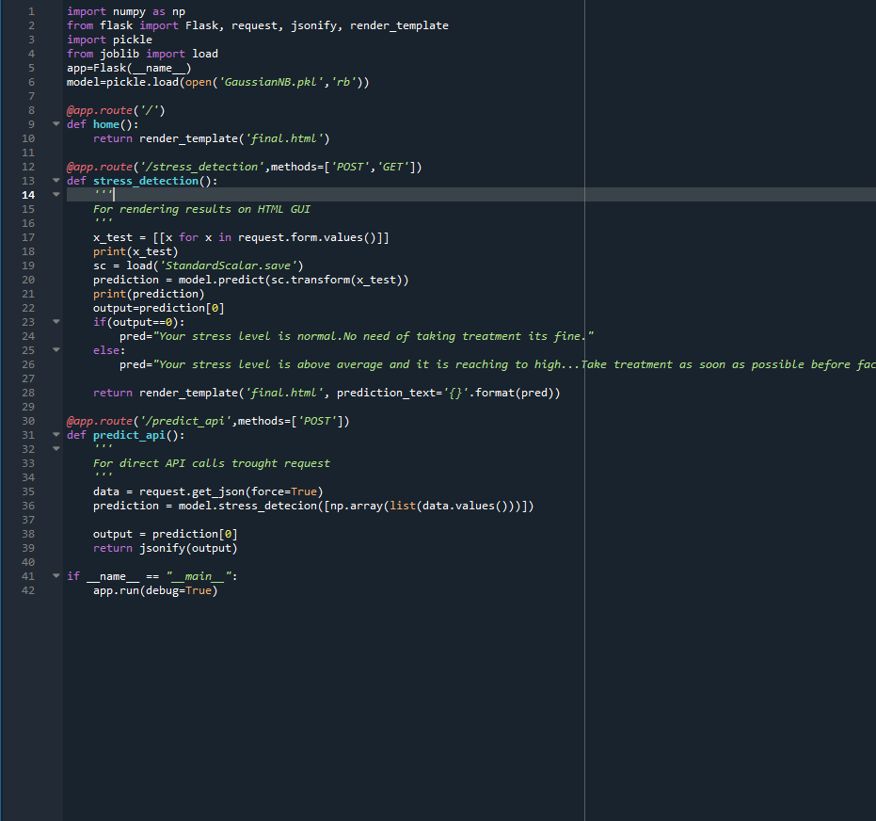

**6.3 HTML Code for web page :**

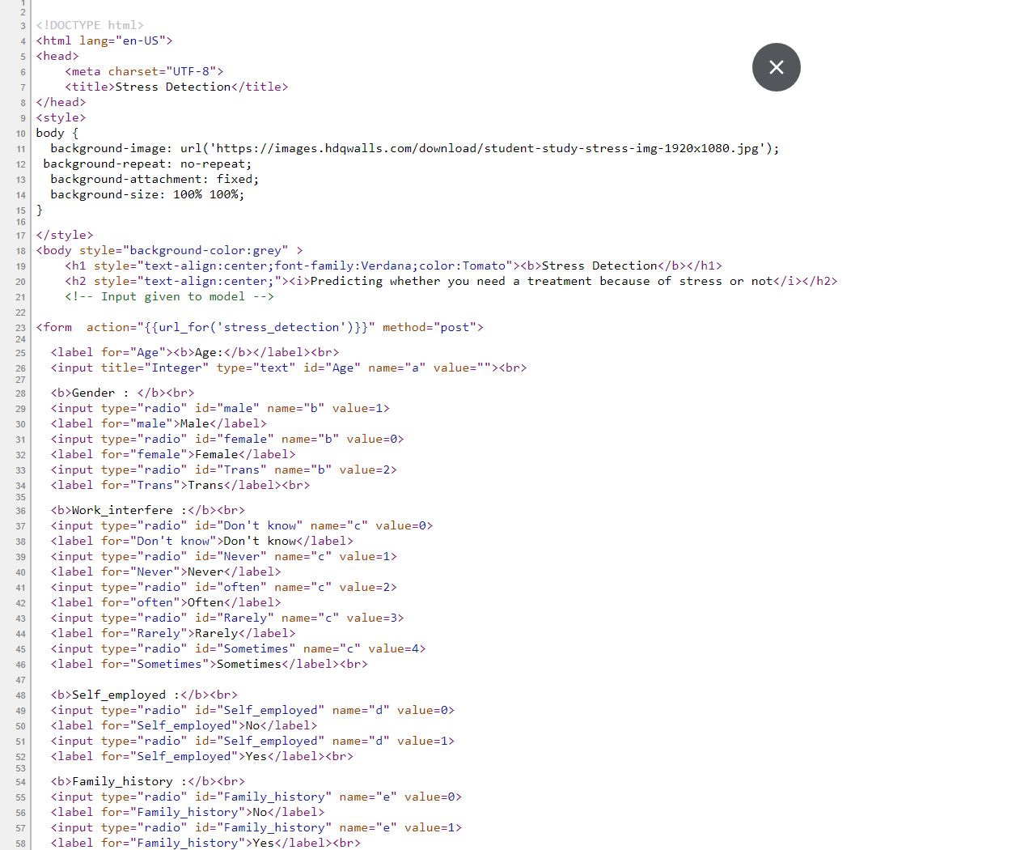

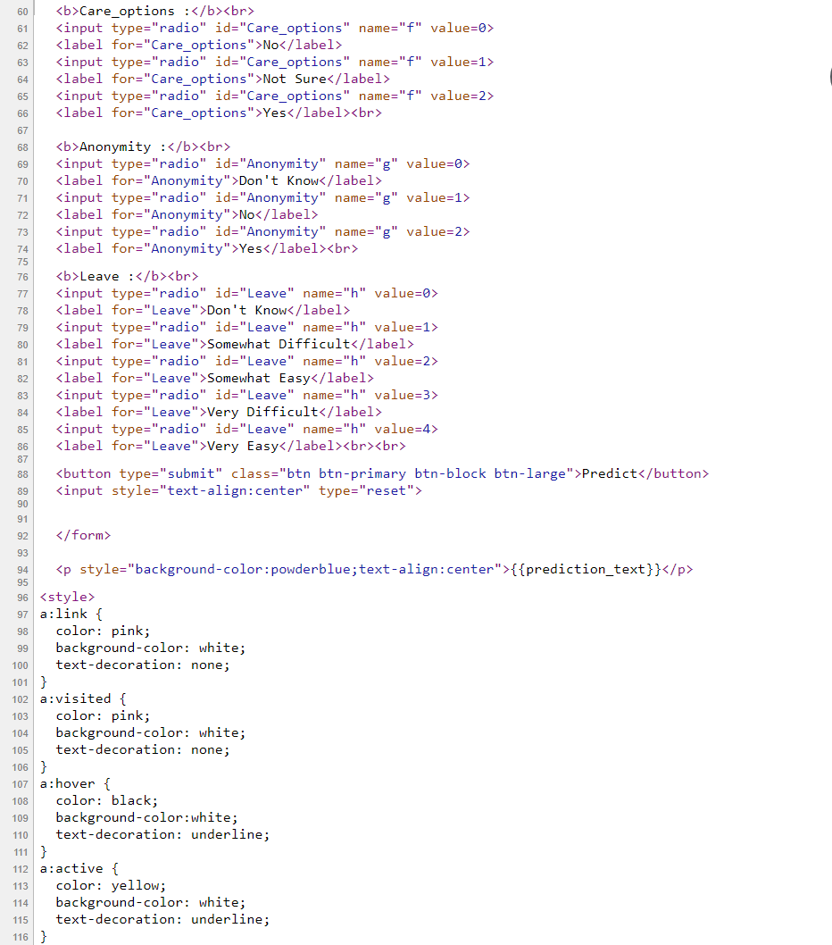



**6.4 Our User Interface :**



**CHAPTER-7**

**RESULTS**

In this section we have outputs and results based on some of the user inputs and some are give by us to check weather our model is working perfectly or not. It includes different types of peep’s stress levels and conditions. You can also find the approximate accuracy results obtained in each case.

**\*Primarily we have created a local network to access the web page :**

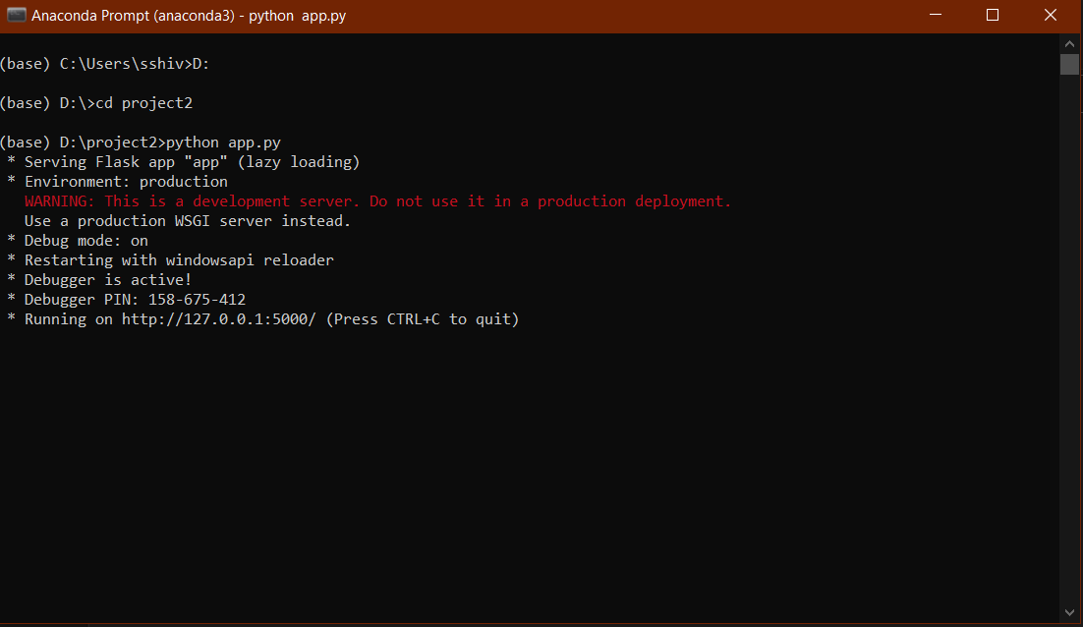

**--When you enter the above url link in any search engine you will directed to the web page , the web page looks as below :**



**Some user data is found to be :**

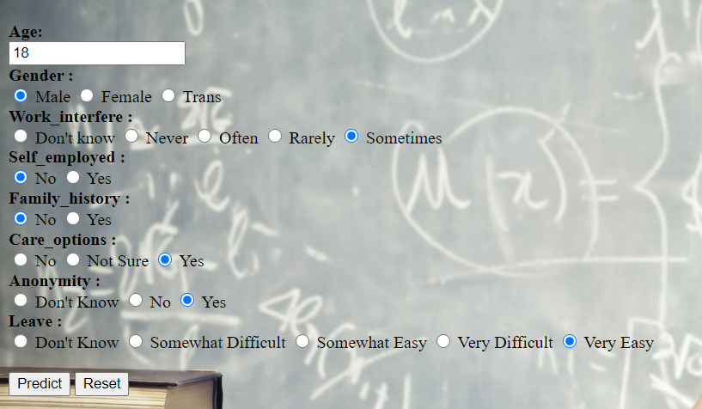

* **When you hit predict the result will be getting like this or else if we hit on reset every value will be cleared….**
* **The result for the above user input is :**



1. **When we look on other user input the result is :**

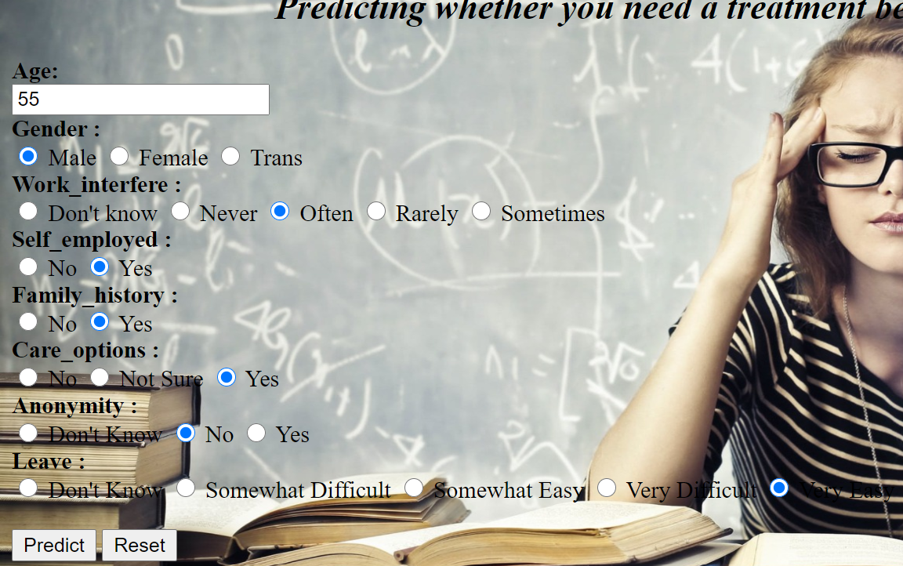

* **When you hit predict the predicted output by the model is :**



**3 . We tested on a random input the model predicted result as shown below :**

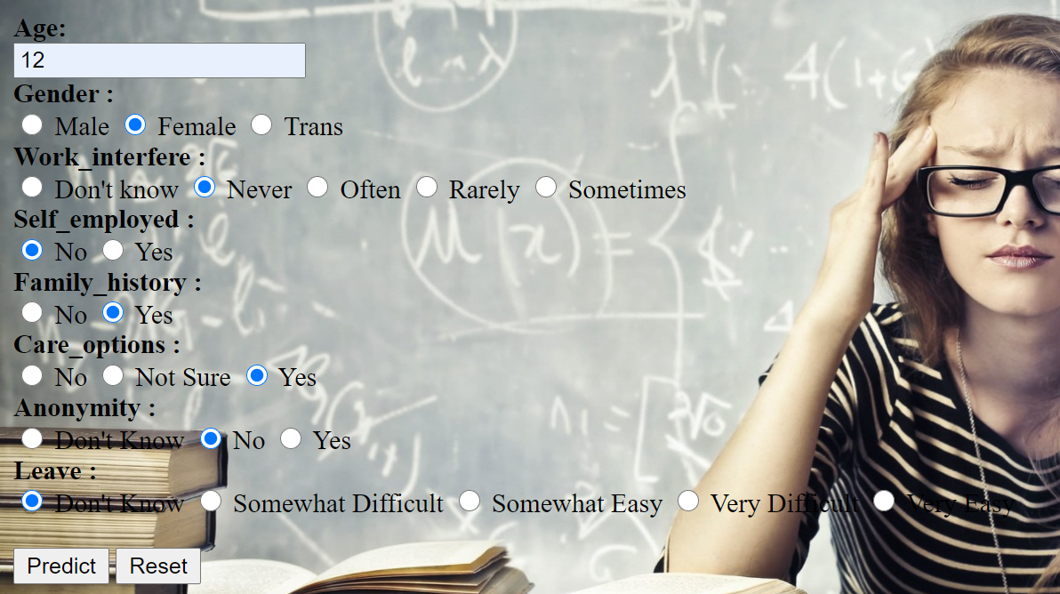

* **When you hit predict the model predicted**



**CHAPTER-8**

**CONCLUSION**

Psychological stress is injures to health. In existing system stress is identified in face to face interview, communication or any other activities. Where two or more people are analyzed by another. In this proposed a system framework for detecting users by asking some of the questions which are related and which causes stress mainly. Here uses a words dictionary rating from -5 to +5 each words . To Classify and predict the data applied the RF and NB algorithm. To improve result accuracy deleted some of the questions which are not mostly useful for the model. Naive Bayes alogithm gave an accuracy of 82%. This implemented system will be helpful to detect Stress by using their answers for some simple questions. In future work, smiley, like and dislike symbols can be considered for categorization of collected data, as it has major contribution to expresses feelings.

**CHAPTER-9**

**REFERENCES**

1. Reshmi Gopalakrishna Pillai, Mike Thelwall, Constantin Orasan, “Detection of Stress and Relaxation Magnitudes for Tweets”, International World Wide Web Conference Committee ACM, 2018.
2. Huijie Lin, Jia Jia, JiezhonQiu, “ Detecting stress based on social interactions in social networks”, IEEE Transactions on Knowledge and Data Engineering, 2017.
3. Mike Thelwall TensiStrength, “Stress and relaxation magnitude detection for social media texts”, Information Processing & Management Science direct, 2017.
4. Jiawei Han, Michelin Kamber, Morgan Kaufman “Data Mining Concepts and Techniques”,2nd Edition, Elsevier, 2003.
5. Munmun De Choudhury, Michael Gamon, Scott Counts, Eric Horvitz, “Predicting Depression via Social Media”, Seventh International AAAI Conference on Weblogs and Social Media, 2013. 6. Thelwall Mike, Kevan Buckley, Paltoglou, “Sentiment strength detection for the social Web”, Journal of the American Society for Information Science and Technology, 2013
6. Thelwall M., Buckley, Paltoglou, Cai, Kappas, “Sentiment strength detection in short informal text”. Journal of the American Society for Information Science and Technology, 2010.
7. Dr. G V Garje, Apoorva Inamdar, Harsha Mahajan, “Stress Detection And Sentiment Prediction: A Survey”, International Journal of Engineering Applied Sciences and Technology, 2016.
8. Alok Ranjan Pall, DigantaSaha, “Word Sense Disambiguation: A Survey", IJCTCM Vol.5 No.3, July 2015.
9. Xinxiong Chen, Zhiyuan Liu, Maosong Sun, “A Unified Model for Word Sense Representation and Disambiguation”, Association for Computational Linguistics, 2014.
10. Huayang Xie, Peter Andreae, Mengjie Zhang, Paul Warren, “Detecting Stress in Spoken English using Decision Trees and